CASITAS DEL MONTE CONDOMINIUM OWNERS ASSOCIATION
Board of Directors Meeting – Agenda
February 21, 2026
Palm Springs, California

I. Call to Order

II. Roll Call
- Bryce Whitaker – President
- Jeff Vierra – Vice President
- Larry Austin – Treasurer
- Erin Rojas – Secretary
- Dennis Highstreet – Voting Member

III. Approval of Previous Meeting Minutes

IV. Personnel & Staffing
- Timeline for BGConsulting
- Staffing structure considerations
- Maria Mills – Office Manager
- Robert Guzman – Maintenance Manager
- Javier Real – Housekeeping Manager

V. Operations & Maintenance
- Maintenance list status update

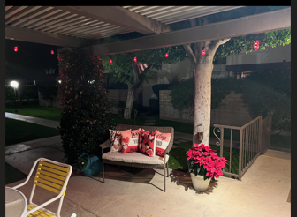
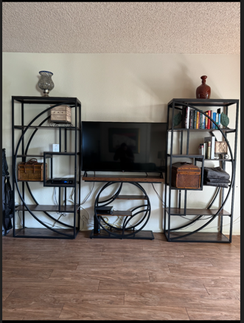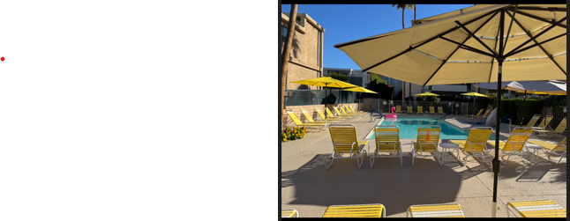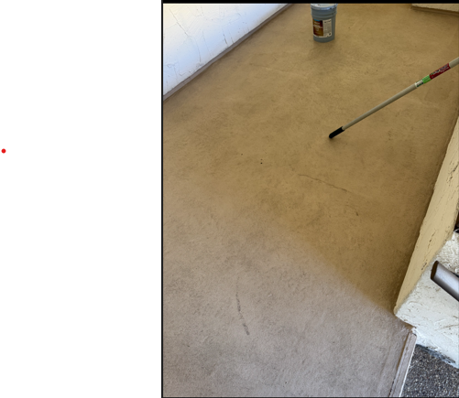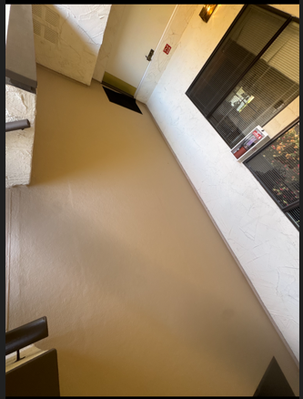

- Curtains replacement – units impacted, vendor, and timeline.
- Tint on windows to protect curtains
- Unit 14 designation – Service Dogs

VI. Financial Review
- Bank high-yield savings account options
- Rental income collected from non-owners through January 31, 2026.
- Owner payment summary – dues collected and delinquency status.

- Clarification of 2026 dues timeline.

VII. Occupancy & Sales
- Monthly and weekly occupancy rate summary.
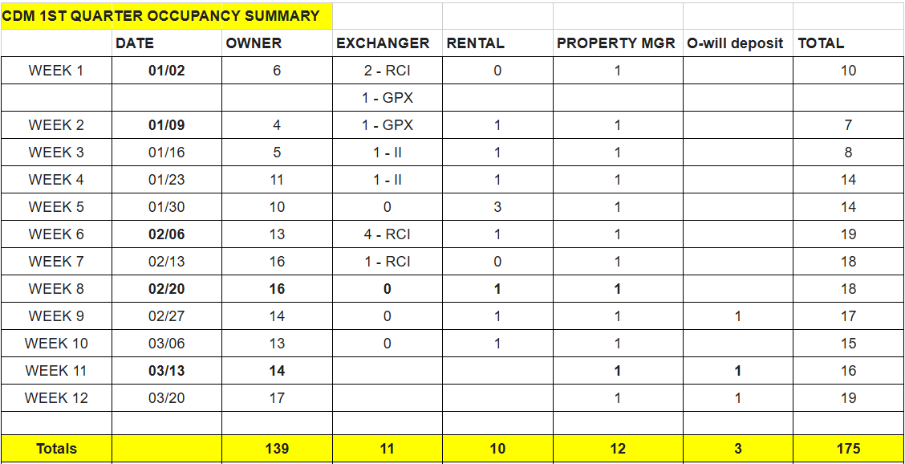

- Owner’s community page – weeks available to trade, sell, or rent
- Official nightly rates
- Security on holiday weekends
- Reinstate Interval International

VIII. Accomplishments & Projects
- New items purchased for units
- Projects currently in progress or upcoming
- Marketing
- Website

IX. Legal and Procedural Updates
- Status update from Association attorney
- Pending matters and next steps
- Please do not call CDM front office for operational updates

X. Open Floor for Owners Questions

XI. Adjournment

